The Basics  Here are some of the most important things that Year 3 children need to know and remember from previous years:  Nouns: These are often known as “naming” words. They name  people, animals, places or things.  Examples: Lucy cat beach table teacher  Adjectives: Describe or give more information about a noun  Examples: bright tired dangerous useless hungry  Verbs: These are often known as “action” words. They describe what a person or thing is doing or being.  Examples: climb bounce write hope is was  Adverbs: Add information about a verb (and sometimes an  adjective or another adverb). They provide information about how, when, where, why or how often something is happening.  Examples: carefully (how) immediately (when) downstairs (where)  therefore (why) always (how often) secondly Perhaps  Sentence Example:  Adjective Noun Verb Adverb  The frightened rabbit jumped backwards.  Practice Question: Label the nouns (a), adjective (b), verb (c) and adverb (d) in the following sentence:  The tired farmer slowly walked home. | Year 3 Punctuation  Apostrophes ‘  There are two reasons to use apostrophes:  - To show possession (something belongs to it)  - To show omission (replaces missing letters in a word)  Apostrophes to show omission (missing letters)  Don’t -short for ‘do not’ - the apostrophe replaces the ‘o’  We’re –short for ‘we are’ - the apostrophe replaces the ‘a’  I’ve - short for ‘I have’ – the apostrophe replaces the ‘ha’  These shortened words are called: contractions  Apostrophes to show possession (belonging)  The girl’s hat (the hat belongs to the girl)  Fred’s lunchbox (the lunchbox belongs to Fred)  The judge’s decision (the decision belongs to the judge)  Inverted Commas “” (speech marks)  Inverted commas, also known as speech marks, are used to show what is being said in a sentence.  Examples:  “I wouldn’t do that if I were you.“ warned the teacher.  Sam asked, “Do you want to come with me?”  The start of speech always needs a capital letter.  There should always be punctuation ( . ! ? ) before you close the inverted commas (speech marks).
Past and Present Tense  Tenses indicate the timing (past, present or future) of an action in a sentence and affect how the verb in a sentence is used.  Past Tense (simple)  I jumped She climbed We shouted James ran Pat ate  Past tense shows an action that began and ended in the past. For this simple form of past tense we usually just add –ed to the end of the verb, but there are some irregular verbs like ran and ate.  Present Tense (simple)  I hope She sings We play Doris walks Peter eats  Present tense shows an action that is happening right now.  Past Progressive Tense  The past progressive tense shows an action that was happening (in progress) at the same time something else happened. It is formed by using was or were with the –ing form of the verb, e.g. was running  I was eating dinner when there was a knock at door.  ‘was eating’ shows that the eating was in progress when the knock at the door happened.  When they were playing in the garden, the ground started to shake.  ‘were playing’ shows that the ground started to shake whilst the playing was in progress.  Present Progressive Tense shows an action is continuing (is in progress) currently. It uses is, are or am with the –ing form of the verb. For example:  We are making pancakes.  I am winning the game.  Luke is finishing his work. | Adverbs to link ideas between sentences  Adverbs add detail to a verb by telling you when, where, how, why or how often something happened. They are really useful in linking ideas together between sentences. Here are some examples:  When and How often – today soon later then next always  Where – here there away everywhere out backwards  Why – therefore consequently as a result  Example: I soon realised that I’d made a big mistake.  Soon tells me when I realised my mistake and suggests it happened shortly after whatever I’d done in the previous sentence.  Example: Therefore, Jack always hides there now.  Sentences can have more than one adverb. This sentence tells me when Jack hides (now), where Jack hides (there), how often Jack hides there (always) and even why Jack hides there (therefore). The ‘therefore’ links Jack’s choice of hiding place to an event that must have been talked about in the previous sentence.  Prepositions to link ideas within sentences  Prepositions link nouns or noun phrases to the rest of the sentence.  before with about of in after because of during for  I went for a long walk after lunch.  She wrote a story about a strange world.  During the long film, Mavis fell asleep.  Practice Question: Circle the 2 adverbs in each sentence:  Yesterday Gina ran off with my lunch.  Later we looked everywhere for Colin’s keys  Can you spot the preposition in each sentence too?
Conjunctions  Conjunctions are used to connect two or more parts of a sentence.  There are two types of conjunctions: co-ordinating and subordinating  Co-ordinating Conjunctions are used to link words, phrases and clauses that are as important as each other (equally important).  Here are some examples: and but or so yet  Example 1: Linking words  I saw my auntie and uncle at the weekend.  The ‘and’ links the nouns auntie and uncle together.  She went swimming and running at the leisure centre.  The ‘and’ links the verbs swimming and running together.  Example 2: Linking phrases  I will tidy my room, but not the whole house.  The ‘but’ links the main clause to the phrase ‘not the whole house’.  Example 3: Linking main clauses  The artist finished her painting but she wasn’t happy with the picture.  The ‘but’ links the main clause ‘The artist finished her painting’ with a second main clause ‘she wasn’t happy with the picture’.  The two main clauses in Example 3 are equally important.  Practice Question (read both pages first)  Circle the conjunction in each sentence below.  Is it a co-ordinating or subordinating conjunction?  - Tom ran home, but I stayed at the park.  - The phone hasn’t worked since it was dropped.  - When Hannah arrived, she was out of breath. | Conjunctions continued…  A main clause makes complete sense by itself and it could be a sentence on it’s own. It will include a subject and a verb.  A subordinate clause doesn’t make sense by itself and depends on being linked to a main clause for it to have meaning. A subordinate clause adds extra information to a main clause by explaining when, where or why something is happening.  Subordinating Conjunctions are used to link subordinate clauses to main clauses. They show that the two parts of the sentence are not equal. Here are some examples:  when before after if because whilst since  Example 4: You can have your pocket money if you complete your homework.  The subordinating conjunction ‘if’ links the main clause, ‘You can have your pocket money’ with the subordinate clause, ‘If you complete your homework”  Subordinating conjunctions can also be used at the start of a sentence.  Example 5: Before eating her dinner, Katie washed her hands.  The subordinating conjunction ‘before’ links the main clause, ‘Katie washed her hands’ with the subordinate clause, which explains when she washed her hands.
Romsey Abbey C of E Primary School
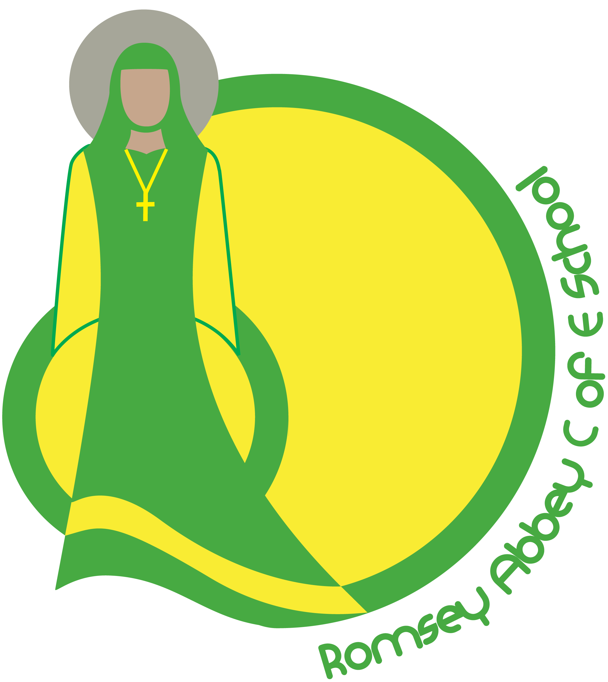

Year 3
Grammar Guide

For Children and Parents
A guide to the key grammar skills and understanding that your child will be learning this year with examples and practice questions to help you support them at home.

